**Problem Set 3- Moderation Analysis with continuous variable**

# 

**Abstract**

In this day and age, it has become very difficult to find new jobs..This study first starts off by investigating whether there’s a relationship between the Difficulty of Finding a New Job and Job Satisfaction. As such, the former will be our independent variables and the latter will be our prediction or dependent variables. The study also further explores if the Level of Education, as a third variable, of a person serves as a moderator to the IV and DV. That is to say, if it enhances or buffers the effect that the predictor (Difficulty of Finding a New Job) has on the outcome (Job Satisfaction). Our results suggest that

**Introduction**

Population is on the rise but jobs are still scarce. Fresh graduates, and otherwise, all have had difficulty in obtaining employment because companies either demand experienced people or follow a very stringent requirement of hiring people from famous schools. People who may not have graduated from IV League Institutes may have to exert extra efforts including obtaining higher degree qualifications in order to appear more attractive and reliable during job hunts.

Therefore, this study analyzes two things. Firstly, it determines whether the difficulty of finding a new job affects an employee’s job satisfaction. Secondly, it carries out the same observation again but with a focus on the level of education that a person has received. That is to say, investigating how the level of education of a person combined with how easy it is to search for a job will affect satisfaction

**Background/Theory**

Job satisfaction is defined as the level of contentment employees feel with their job. While this goes beyond their daily duties to cover satisfaction with team members/managers, for this context we will be restricting job satisfaction as the level of contentment employees feel with the work they do and what they achieve through it.

Find Job is defined as the level of ease that a person faces in either switching to a new company or getting their first job.

Level of Education refers to the formal degrees that dictates the academic qualifications of a person. Whether a person has received education formally only up to their school or if they also passed University or even if they are now pursuing postgraduate studies.

Since, the study is investigating whether the Find Job affects Job Satisfaction, then the former will be the Independent variable while the latter will be the dependent variable. As such, this will also be our first null hypothesis where we theorize that variety of work does not affect job satisfaction.

*H1: There is no relationship between ease of Finding a New Job and Job Satisfaction.*

The studies are also investigating how the relationship between the two variables would vary when a third variable, level of education, is introduced. How does the level of education of a person interact with the level of ease of finding a job to influence Job Satisfaction. Level of Education could add onto a positive or negative relationship between the Independent and Dependent variables or even have no affect. As such, this will be our second null hypothesis where we theorize that the Level of Education, as a third variable, has no effect on the relationship of the two variables.

*H2: Level of Education, as the third variable, has no effect on the relationship between Finding a New Job and Job Satisfaction.*

**Methods**

To study the effect of ease in finding a new job, with regards to the level of education on job satisfaction we have used the General Society Survey (GSS) data. The GSS data has been studying the growing complexity of American Society and has been monitoring societal change since 1972. The dataset has 57061 records. Table 1 below shows the summary of the data.

Table 1

Means, standard deviations, and correlations with confidence intervals

|  |  |  |  |  |  |
| --- | --- | --- | --- | --- | --- |
| Variable | *M* | *SD* | 1 | 2 | 3 |
|  | | | | | |
| 1. JobSat | 3.30 | 0.81 |  |  |  |
| 2. Level of Education | 13.03 | 5.55 | .03** |  |  |
|  |  |  | [.02, .04] |  |  |
| 3. FindNew | 1.85 | 0.81 | .06** | .01 |  |
|  |  |  | [.04, .07] | [.04, .07] |  |
|  | | | | | |

Note. M and SD are used to represent mean and standard deviation, respectively. Values in square brackets indicate the 95% confidence interval. The confidence interval is a plausible range of population correlations that could have caused the sample correlation (Cumming, 2014). * indicates p < .05. ** indicates p < .01.

We then do a simple slope analysis to interpret how the interaction between ease in finding a new job and Level of Education variable affects the level of job satisfaction.

**Results**

The regression with the interaction of the level of education variable with ease in finding a new job shows that the level of education and ease in finding a new job are not significant predictors of Job Satisfaction. Along with these two, the interaction of the level of education and ease in finding a new job is also not a significant predictor of job satisfaction. The effect size of the level of education variable on job satisfaction is -0.001686 in other words with one unit increase in the scale of education level the job satisfaction would decrease by -0.001686. Similarly, the effect size of ease in finding a new job on job satisfaction is 0.021123 i.e. a unit increase in the scale of ease in finding a new job would increase job satisfaction by 0.02123. The effect size of the interaction term is 0.002407. Since the predictors are not significant these effect sizes would not be significant as well. The p-value of ease in finding a new job is 0.3025, the p-value of the level of education is 0.5353 and the p-value of the interaction term is 0.0876. The summary of the regression model can be found below in Table 2.

Table 2

Summary of the model results

__________________________________________________________________________________________________________________

|  |
| --- |
| Call:  lm(formula = JobSat ~ FindNew * EDUC, data = GSS.data)  Residuals:  Min 1Q Median 3Q Max  -2.8507 -0.3316 -0.2683 0.6778 0.7389  Coefficients:  Estimate Std. Error t value Pr(>|t|)  (Intercept) 3.239157 0.039366 82.282 <2e-16 ***  FindNew 0.021213 0.020575 1.031 0.3025  EDUC -0.001686 0.002720 -0.620 0.5353  FindNew:EDUC 0.002407 0.001409 1.708 0.0876 .  ---  Signif. codes: 0 ‘***’ 0.001 ‘**’ 0.01 ‘*’ 0.05 ‘.’ 0.1 ‘ ’ 1  Residual standard error: 0.7773 on 18567 degrees of freedom  (38490 observations deleted due to missingness)  Multiple R-squared: 0.003649, Adjusted R-squared: 0.003488  F-statistic: 22.67 on 3 and 18567 DF, p-value: 1.215e-14 |
|
|
|
|
|

The slope analysis shows that the effect of ease in finding a new job when the education is 8, 12 or 16 years is significant since the p-value is 0 in each case. 8 years of education has a positive effect of 0.04 on job satisfaction, 12 years of education has a positive effect of 0.05 on job satisfaction and 16 years of education has a positive effect of 0.06 on job satisfaction.

From the slope analysis it seems that ease in finding a new job has a higher effect on job satisfaction with the increase in education level value of effect is 0.06 for 16 years of education.

Table 3

Summary of the simple slope analysis

__________________________________________________________________________________________________________________

|  |
| --- |
| SIMPLE SLOPES ANALYSIS  Slope of FindNew when EDUC = 8.00:  Est. S.E. t val. p  ------ ------ -------- ------  0.04 0.01 3.77 0.00  Slope of FindNew when EDUC = 12.00:  Est. S.E. t val. p  ------ ------ -------- ------  0.05 0.01 6.69 0.00  Slope of FindNew when EDUC = 16.00:  Est. S.E. t val. p  ------ ------ -------- ------  0.06 0.01 7.67 0.00 |
|
|
|
|
|

The interaction plot looks like fanning out. It also shows that as the ease in finding a new job increases the level of job satisfaction increases for each education year. The slope is the highest when the education is 16 years.

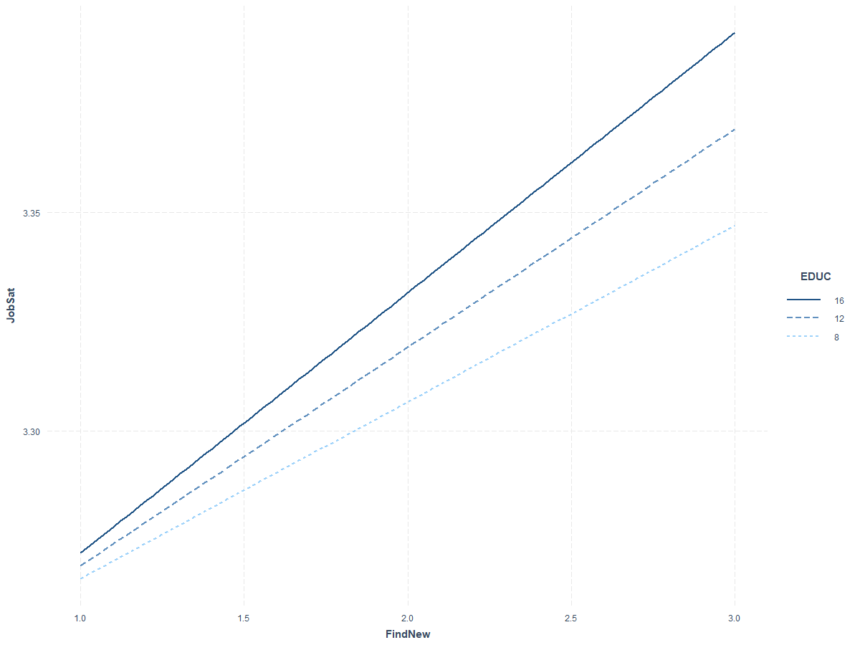

Figure 1: Interaction plot of easiness in finding a new job and level of education vs job satisfaction.

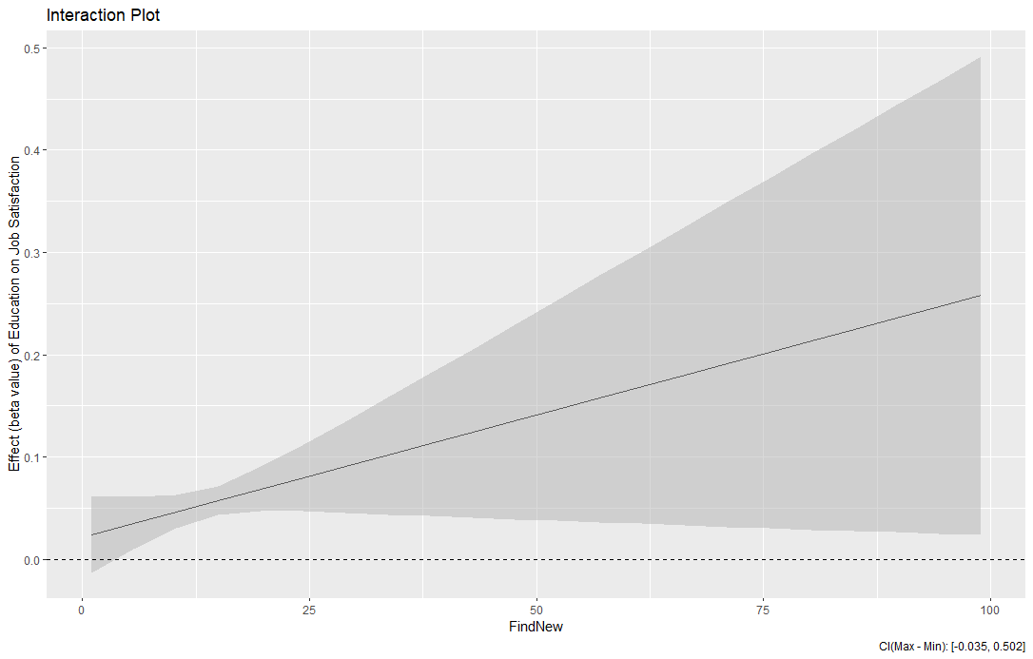

Figure 3: Interaction plot Effect(Beta Value) of Education on Job Satisfaction vs ease in finding a new job.

The Johnson Neyman analysis shows that if the value of ease in finding a new job is in the interval [1.66-8.39] the slope of education would be significant. The range of values of ease in finding a new job are in the range [1-3] hence the values 2 and 3 are significant and affect the slope of the level of education.

Table 4

Summary of Johnson Neyman analysis

__________________________________________________________________________________________________________________

|  |
| --- |
| JOHNSON-NEYMAN INTERVAL  When FindNew is INSIDE the interval [1.66, 8.39], the slope of EDUC is p < .05.  Note: The range of observed values of FindNew is [1.00, 3.00]  SIMPLE SLOPES ANALYSIS  Slope of EDUC when FindNew = 1.00:  Est. S.E. t val. p  ------ ------ -------- ------  0.00 0.00 0.46 0.65  Slope of EDUC when FindNew = 2.00:  Est. S.E. t val. p  ------ ------ -------- ------  0.00 0.00 2.54 0.01  Slope of EDUC when FindNew = 3.00:  Est. S.E. t val. p  ------ ------ -------- ------  0.01 0.00 2.60 0.01  Slope of EDUC when FindNew = 4.00: |
|
|
|
|
|

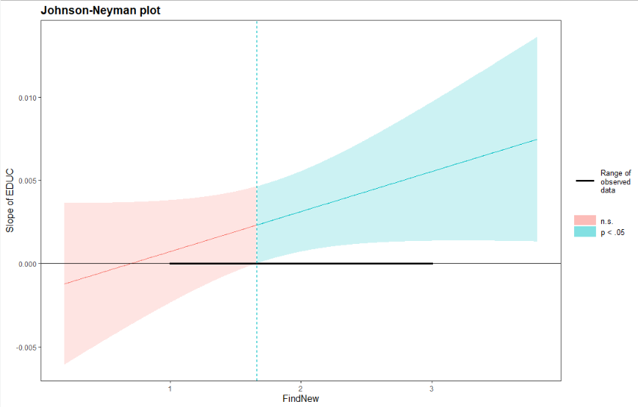

Figure 2: Johnson-Neyman analysis of ease in finding a new job and level of education.

**Discussion**From the results we can see that none of the predictors including the interaction terms are not significant predictors of job satisfaction. We proceeded with the slope analysis to interpret the effect of the interaction term however since the interaction term did not come out to be significant hence we can not reject any of our null hypothesis.

**Bibliography**

* *Verhofstadt, Emy. (2003). The impact of education on job satisfaction in the first job*
* *Dalfgauu, Jose. (2006). The effect of job satisfaction on job search.*

**Appendix**

# GSS Data

The General Society Survey (GSS) has been studying the growing complexity of American Society and has been monitoring societal change since 1972. The aim of GSS is to gather data on contemporary American society in order to monitor and explain changes and constants in behaviors, attitudes and other attributes; to examine the functioning and structure of the society as well as understand the role different relevant subgroups play. The GSS aims to gather data on contemporary American society in order to monitor and explain trends and constants in attitudes, behaviors, and attributes; to examine the structure and functioning of society in general as well as the role played by relevant subgroups and to make high-quality data easily available for students, scholars, policy makers and others. The GSS includes questions like national spending priorities, crime, marijuana use and punishment, race relations, quality of life, confidence in institutions and so on and so forth. ("General Social Survey (GSS) | NORC.org", n.d.)

Code

#install packages

install.packages('interactions')

install.packages('apaTables')

install.packages('interplot')

#import packages

library(interactions)

library(apaTables)

#load data

source('GSS-CleanData.R')

# moderation

mydata <- GSS.data[c('JobSat','EDUC','FindNew')]

nrow(mydata)

apa.cor.table(mydata, filename="table1.doc")

# moderation

summary(lm(JobSat ~ FindNew * EDUC, data = GSS.data))

# plot interaction

Model.int.2 <- lm(JobSat ~ FindNew * EDUC, data = GSS.data)

sim_slopes(Model.int.2, pred = FindNew, modx = EDUC, johnson_neyman = FALSE, modx.values = c(8,12,16))

interact_plot(Model.int.2, pred = FindNew, modx = EDUC, modx.values = c(8,12,16))

# add in Johnson-Neyman analysis

sim_slopes(Model.int.2, pred = EDUC, modx = FindNew, modx.values = c(1,2,3,4), jnplot = TRUE)

cat("\014") #clear output

# less common, but should be the new norm

# I imagine it's complicated to do in any platform but R. It's three lines of code in R

library(interplot)

plot.Model.int2 <- interplot(m = Model.int.2, var1 = "FindNew", var2 = "EDUC")

plot.Model.int2 + labs(x = "FindNew", y = "Effect (beta value) of Education on Finding new job", title = "Interaction Plot") + geom_hline(yintercept = 0, linetype = "dashed")